The article is published in Ukrainian (Russian) in the journal.
The English text is given in the author's version.
UDC 615.451.2 +616.594.14
THE DEVELOPMENT OF STRUCTURE OF EMULSION BASIS WHILE CREATING THE MEDICAL COSMETIC PRODUCTS TO BE USED AT ANDROGENIC ALOPECIA
I.O. Yarema, M. I. Feodorovska
Ivano-Frankivsk National Medical University
Keywords: androgenetic alopecia, emulsion base, emulsifiers, gelatinizators, biopharmaceutical research, microscopic research.
Androgenetic Alopecia (AA) treatment nowadays is still a difficult task of tryhology and cosmetology as the range of medical drugs (MD), which would affect the pathogenetic link of disease and were comfortable and safe to use, is limited. Bearing all that in mind an increased attention is paid to substances of plant origin based on phytosterols and flavonoids. Phytosterols are the inhibitors of the 5α-reductase – enzyme responsible for the occurrence of AA while flavonoids strengthen the cell wall and improve skin circulation. Taking all that into account it is important to say that the development of medical product ( MP) in the form of emulsions for external use which contains dry extract of Saw palmetto (rich in phytosterols) and the tincture of Japanese Sophora (source of flavonoids) is actual. The pharmacological activity of drugs for dermatological use largely depends on the nature of the base-carrier of active substances. Therefore, the article presents the results of research of the emulsion base composition development. On the first stage 16 bases of emulsion formulations were processed and to their composition the pumpkin seed oil was injected as the oil phase. Emulsifiers and solvents gelatinizators (sodium alginate, xanthan gum, carboxymethylcellulose, Carbopol) were used as regulators of heterogeneous system. With bases that were homogeneous in appearance, the identification of their colloid and thermal stability were being made immediately after their manufacturing. The bases that have been tested were subjected to microscopic and biopharmaceutical research that revealed the size and homogenity of the particles of oil phase and determine the effectiveness of the release of biologically active substances (BAS) from the base-carriers. On the basis of these studies which have been carried on it was found that optimum properties have the bases that contain gelatinizators of Carbopol, sodium alginate and xanthan gum, emulsifiers – Tween-20 and cetyl alcohol.
Daily Hair Loss is a physiological phenomenon. However, because of various reasons (the effects of stress and toxins, hormonal imbalances, infectious diseases, inflammatory and autoimmune processes, scalp trauma, etc.) phases synchronization of hair life cycle is broken. As a result, there is an abnormal loss of hair (alopecia) [11].
One of the most common forms of hair loss that occurs in both men and women is androgenic alopecia (AA) – a progressive alopecia caused by the action of androgens on the hair follicle in patients with hereditary predisposition [ 6, 12 , 13]. Treatment of AA today is a hard task in dermatology since nomenclature of drugs that could affect the pathogenetic link of the disease is limited and is used only as drugs based on minoxidil (2-5 % solution for local use) and finasteride (tablets for oral administration). These drugs are characterized by a number of side effects, the most important of which are: for minoxidil – the need for long-term therapy, the lack of effect on pathogenic links of the disease, high cost, finasteride is contraindicated for women because of embryotoxic effects and in men it causes impaired sexual function [8, 10, 14].
Taking all that into account , the development of herbal medicines that affect the pathogenesis of AA (phytosterols of palm Sabala extract) circulation of the hair follicles (Sophora Japanese teas flavonoids) and are safe in case of prolonged external use is an important task of modern pharmaceutical science [7, 9].
Therefore, the purpose of the work is to study the optimal composition of the main phyto emulsion carrier intended for topical use in androgenic alopecia.
Materials and methods
In the first phase of research the development of a liquid emulsion base was carried out, which would allow to quickly and fully release the active ingredients, while it would be fully absorbed by the scalp without destroying the water-lipid layer and did not burden hair. Previous practical experience suggests that for the creation of stable oil in water (o/w) emulsion system is necessary to use a large number of strong emulsifying agents [1, 4]. The developing dosage form is intended for long-term and frequent use, and thus an excessive amount of emulsifiers may cause local irritation, destruction of cutaneous epidermal barriers. Therefore, to obtain a stable emulsion o/w and w/o emulsifiers, the solution of high molecular compounds (HMC) should be added to the compounds of heterogeneous system. When selecting emulsifiers we concentrated our attention on substances which are used in the composition of many cosmetic products for hair and skin, namely: Twin -20, SAS of sweet almond oil (of the first kind), lanolin erkalan (PEG - 75), cetyl alcohol (of the second kind). As gelatinizators, sodium alginate, xanthan gum (of natural origin), carboxymethylcellulose and Carbopol (of synthetic origin) were chosen. As an oil phase pumpkin seed oil was used, according to its properties, antioxidant and folikul protective effect due to the content of polyunsaturated fatty acids, phytosterols, vitamins and microelements [9].
The prepared bases, were evaluated by organoleptic characteristics, also it was determined their colloidal and thermal stability. In samples that have been already tested it was examined the bioavailability and dispersion using standard of State Ukraine Pharmacopeia, 1-st edition, Unit "Soft drugs for topical application" [2]. The degree of dispersion and the definition of linear particle size of the oil phase was performed with an electron microscope «Delta Optical Genetic Pro» with integrated camera (lens 40/ 0, 65 160/0.17; eyepiece WF 10×/18). The effectiveness of the release of biologically active substances from basis under study was determined by agar diffusion. 10% of Sophora Japonica tincture was added to the bases. As a reagent for phenolic compounds the solution of iron (III) chloride was used. Petri dishes with the test samples were placed in a thermostat and at the temperature of 37⁰C the diameter of stained areas was measured every 15 minutes [2, 3].
Results and their discussion
The bases compositions are shown in Table 1. The basis which were not layered (№ 3, 4, 5, 6, 8, 8*, 12, 15), were subjected to determination of colloid and thermal stability immediately after their production. In addition for consumer parameters evaluation the calculation of the complex index of quality was done [5]. The results are presented in Table 2. According to the table it is clear that the samples of sodium alginate, xanthan gum and Carbopol, which include cetyl alcohol and Tween-20 as emulsifiers are quite stable.
These bases were also investigated by studying the dispersion of the oil phase and bioavailability. While conducting microscopic studies it was revealed that the samples number 4, 12 and 8* are not homogeneous by dispersion, since a significant percentage is given to large fractions (Fig. 1 A-C). Average particle size of the dispersed phase is in the range of 6.2 to 8.1 microns. Basis of number 5 and 8 are more homogeneous with an average particle size of the dispersed phase 3.1 (Fig. 1-D) and 4.1 microns, respectively (Fig. 1 E). The smallest and homogeneous particle size of the dispersed phase has the bases № 6 with Carbopol as gelatinizators (Fig. 1-F).
Homogeneity and a high degree of dispersion of the oil phase affect the equality of distribution of active ingredients and their rate of release from the basis and, consequently, the effectiveness of pharmacological action. Biopharmaceutical studies have shown (Fig. 2) that the best diffusion of active substances of phenolic nature in agarose gel comes from bases number 6.
Thus, on the grounds of microscopic and biopharmaceutical research, the definition of colloid and thermal stability it was found out that the optimum properties have the bases № 5, № 6 and № 8, containing gelatinizators Carbopol, sodium alginate and xanthan gum, emulsifiers – Tween-20 and cetyl alcohol. In future studies, we plan to study the rheological properties of these bases to study their technology, and choose the best way to include the active ingredients to the dosage form.
CONCLUSIONS
1. Based on the investigation of colloid and thermal stability it was determined that the most resistant to the layering have the bases, to which as an emulsifier Tween-20 and cetyl alcohol were added.
2. Based on the results of microscopic studies we have found that the greatest degree of dispersion has the base № 6, which contains gelatinizators Carbopol.
3. Biopharmaceutical studies found out that samples of the bases with Carbopol, sodium alginate and xanthan gum actively release the active ingredients, including the highest rates, which were observed at the base with Carbopol.

Name of the component | №1 | №2 | №3 | №4 | №5 | №6 | №7 | №8 | №8* | №9 | №10 | №11 | №12 | №13 | №14 | №15 | №16
Oil pumpkin | 5,0 | 5,0 | 5,0 | 5,0 | 5,0 | 5,0 | 5,0 | 5,0 | 5,0 | 5,0 | 5,0 | 5,0 | 5,0 | 5,0 | 5,0 | 5,0 | 5,0
Sodium alginate | 1,0 | - | - | - | 1,0 | - | - | - | - | 1,0 | - | - | - | 1,0 | - | - | -
Carbopol | - | 1,0 | - | - | - | 0,5 | - | - | - | - | 1,0 | - | - | - | 1,0 | - | -
Carboxymethylcellulose | - | - | 1,0 | - | - | - | 1,0 | - | - | - | - | 1,0 | - | - | - | 1,0 | -
Xanthan gum | - | - | - | 1,0 | - | - | - | 1,0 | 0,5 | - | - | - | 1,0 | - | - | - | 1,0
Tween-20 | 3,0 | 3,0 | 3,0 | 3,0 | 3,0 | 3,0 | 3,0 | 3,0 | 3,0 | - | - | - | - | - | - | - | -
SAS with sweet almond oil | - | - | - | - | - | - | - | - | - | 3,0 | 3,0 | 3,0 | 3,0 | 3,0 | 3,0 | 3,0 | 3,0
Lanolin erkalan (PEG-75) | 3,0 | 3,0 | 3,0 | 3,0 | - | - | - | - | - | 3,0 | 3,0 | 3,0 | 3,0 | - | - | - | -
Cetyl alcohol | - | - | - | - | 3,0 | 3,0 | 3,0 | 3,0 | 3,0 | - | - | - | - | 3,0 | 3,0 | 3,0 | 3,0
Purified water | at 100 | at 100 | at 100 | at 100 | at 100 | at 100 | at 100 | at 100 | at  100 | at  100 | at 100 | at  100 | at 100 | at  100 | at 100 | at 100 | at 100
Table 1
Investigated forms of the bases

Table 2
Index | №3 | №4 | №5 | №6 | №8 | №8* | №12 | №15
Homogeneity | + | + | + | + | + | + | + | +
Thermostability | - | + | + | + | + | + | + | -
Colloid stability at 6000 rev / min | - | + | + | + | + | + | + | -
Comprehensive Quality Index (max 10) | 6,6 | 7,2 | 7,3 | 7,4 | 8,0 | 8,1 | 8,0 | 8,0
Research quality indicators of emulsion bases
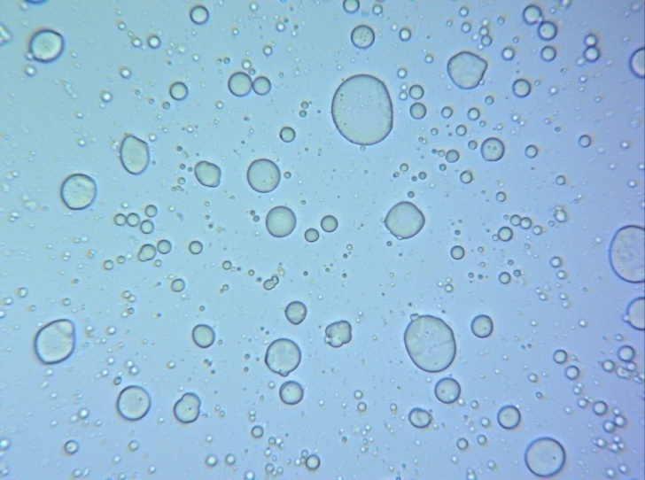
A
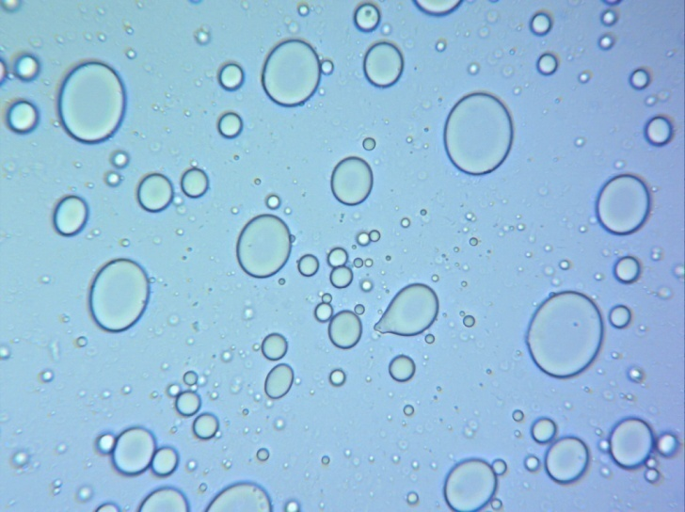
B
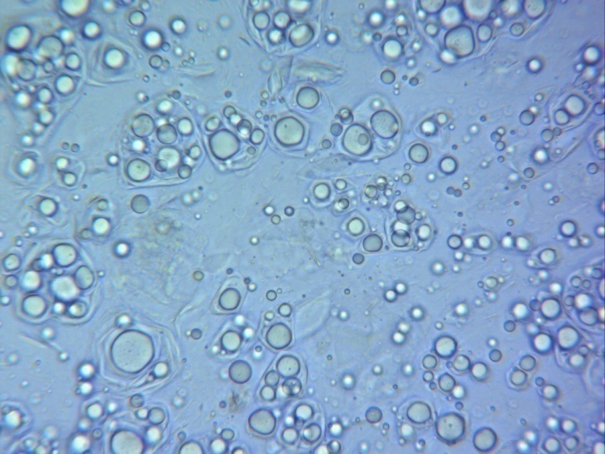
C
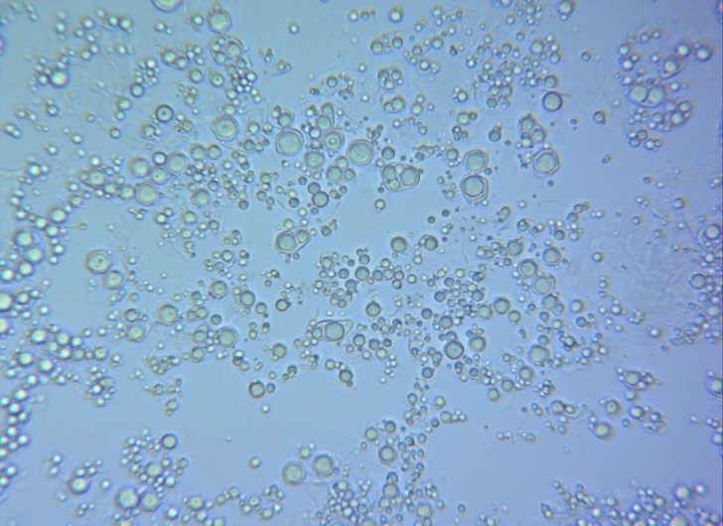
D
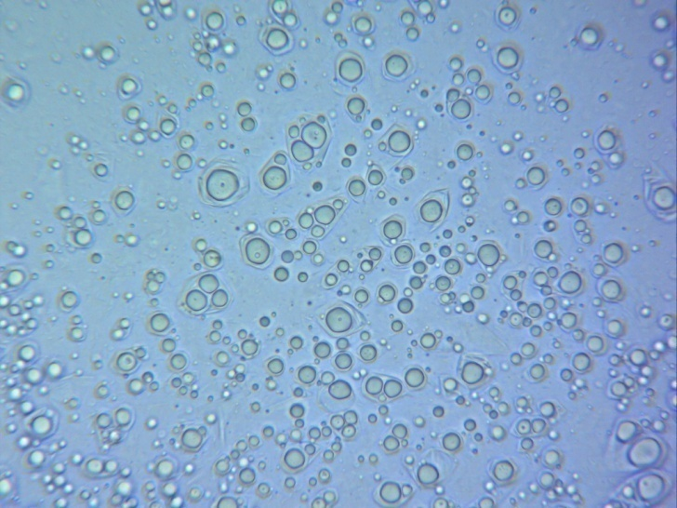
E
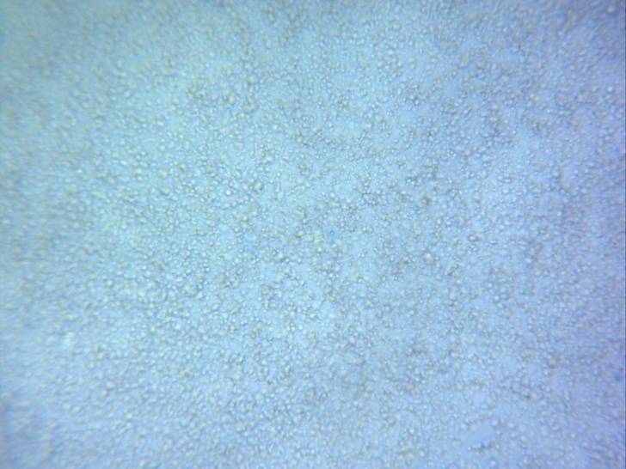
F
Fig. 1 Dispersion of particles of oil phase:
A - bases number 4; B - bases number 12;
C - bases number 8*; D - bases number 5; E - bases number 8; F - bases number 6.

d, mm
Time  Number of Bases | 15 min. | 30 min. | 45  min | 60 min. | 75 min. | 90  min
 | D_{min.}, mm | D_{min.}, mm | D_{min.}, mm | D_{min.}, mm | D_{min.}, mm | D_{min.}, mm
№ 4 | 15 | 16 | 17 | 18 | 20 | 20
№ 5 | 16 | 17 | 19 | 20 | 20 | 20
№ 6 | 18 | 20 | 21 | 22 | 23 | 24
№ 8 | 15 | 17 | 18 | 19 | 20 | 21
№ 8* | 16 | 17 | 19 | 20 | 21 | 21
№ 12 | 16 | 17 | 19 | 20 | 21 | 21

Fig. 2 Diagram of the rate of release of biologically phenolic nature of the bases in agar gel

REFERENCES
- Гладышева С.А. Оптимизация исследований по выбору основы-носителя мягких фармакотерапевтических средств для профилактики алопеции / С.А. Гладышева, Е.В. Гладух // Запорожский мед. журнал. – 2008. – №6. – С. 70–71.
- Державна Фармакопея України / Державне підприємство «Науковий-експертний фармакопейний центр». – 1-е вид. – Харків: РІРЕГ, 2001. – 526 с.
- Креми косметичні. Загальні технічні умови: ДСТУ 4765:2007. – [Чинний від 2009-01-01] – К.: Держспоживстандарт України, 2008. – 7 с. – (Національний стандарт України).
- Нікітіна М.В. Обґрунтування вибору емульгаторів з метою розробки емульсії 1 роду з молочною кислотою / М.В. Нікітіна, І.І. Баранова, Н.О. Ніколайчук // Фармація. – 2010. – №4(23). – С. 51-53.
- Павх О.І. Розробка складу лікувально-косметичного засобу для профілактики випадіння волосся / О.І. Павх, Л.В. Соколова, Г.Р. Козир, О.М. Барна // Запорожский медицинский журнал.– 2012. – №3(72). – С. 26-27.
- Святенко Т.В. Алопеция: классификации, этиопатогенез, клинические проявления, современные возможности терапии / Т.В. Святенко, Л. А. Андриуца // Мedix. Anti-Aging – 2011. – №1(19). – С. 65-69.
- Сhatterjee S. Saw palmetto (Serenoa repens) in androgenic alopecia / S.Сhatterjee, S. K. Agrawala // Natural Product Radiance. – 2003. - №2(6). – С. 302-305.
- Messenger A.G. Minoxidil: mechanisms of action on hair growth / A.G.Messenger, J. Rundegren // British Journal of Dermatology. – 2004. - №8 (150). – С.186-194.
- Patil K.T. Herbal medicines as an effective therapy in hair loss / Research Journal of Pharmaceutical, Biological and Chemical Sciences. – 2010. - №1 (2). – С.773-780.
- R. Kučerová, M. Bienová, R. Novotný et al.Current therapies of female androgenetic alopecia and use of fluridil, a novel topical antiandrogen // Scripta medica. – 2006. - №1 (79). – С.35-48.
- Stefanato C.M. Histopathology of alopecia: a clinicopathological approach to diagnosis // Histopathology. – 2010. - № 56. – С.24-38.
- Trüeb R.M. Molecular mechanisms of androgenetic alopecia / Experimental Gerontology. – 2002. – т. 37 . – С. 981-990.
- Wang E. Etiopathogenesis of alopecia areata: Why do our patients get it? / E. Wang, K. J. McElwee // Dermatologic Therapy. – 2011. – №1 (24). – С. 337-347.
Yip L. Role of genetics and sex steroid hormones in male androgenetic alopecia and female pattern hair loss: An update of what we now know / L. Yip, N. Rufaut, R. Sinclair // Australasian Journal of Dermatology. – 2011. - №52. – С.81-88.

