The article is published in Ukrainian (Russian) in the journal. The English text is given in the author's version.
UDC 615.454.1:616-001.4
USTIFICATION OF THE BASIS TO CREATE SOFT MEDICAMENT FOR THE TREATMENT WOUND PROCESS
V.V. Shmatenko
Ukrainian Military Medical Academy
Summary. Particular attention is to create medicines (drugs ) for the treatment of purulent - inflammatory processes is the choice of basis. In modern manufacturing dosage forms for the treatment of purulent - inflammatory drugs on the preferred hydrophilic bases, which can be applied to the wound surface without disturbing the perspiration. Lack of domestic preparations for the treatment of wound healing process in the transition from the first phase to the second, promoting epithelialization process , provide relevant results for the creation of new combined ointments for the treatment of wound healing. One of the most important indicators of specific action drugs for the treatment of wound healing is the osmotic activity, thanks to which the dehydration of microbial cells, which causes a significant reduction in biological activity and microbial resistance.
Method of dialysis through a semipermeable membrane in in vitro experiments we studied the osmotic activity of samples of ointment bases to justify an optimal basis of the carrier and the development on this basis ointment antibacterial and anti-inflammatory action. It was established experimentally that the best dehydrating properties has a base which includes alloy PEO 400 and -1500.
When creating ointments for the treatment of wound healing at its transition from the first to the second phase should be noted that more should be considered optimal combined basis, which provide high effect release of drug substances that enhance their stimulating effect, as well as the basics that create a moderate level of injury dehydration .Therefore, in the experiment in order to create a combined emulsion ointment bases chosen are emulsifiers Center - MSH tsitostearilovy and alcohol in an amount of 3 % and 5 % respectively. As oil phase used vaseline oil - 20 % (aqueous phase - purified water - up to 100 %). On the basis of these studies, we grounded osmotic composition emulsion ointment bases: PEO - 400 -4 % PEO -1500 – 1 %, 3 % MSG, tsitostearilovogo alcohol – 5 %, 5 % glycerol, vaseline oil - 20 % purified water - up 100 %.
Key words. The osmotic activity, base carrier, the hydrophilic non-aqueous solvent, process of the wound, soft medicine.
Introduction
Pharmaceutical practice using theoretical and practical achievements of general biological and medical sciences and engineering allows the new position to approach the problem of increasing the effectiveness of medical treatment of wounds. The theoretical basis for this type of development is proven that the principle of unity of laws biological wound healing, regardless of its origin (burn, traumatic, or infectious) and location (internal or external coverings of) [1, 4].
Regardless of the type of wound and tissue healing scale loss of any wound includes certain phases that overlap in time and can not be sharply separated. When you split into phases to consider major morphological changes during the process of reparation [9].
For the treatment of local infectious and inflammatory diseases commonly used soft medicinal forms of domestic and foreign production [7]. These drugs on many parameters do not meet modern medical and biological requirements. Yes, they are made primarily on two types of ointment bases: water-soluble (alloys polyethylene) and emulsion [5]. Emulsion foundations are not able to adsorb sufficiently purulent wound discharge and polietylenoksydni [10] the basics of the odnonapravlenosti osmotic processes leading to osmotic shock cell granulation tissue and mucous membranes. In clinical practice, it is shown how the death of granulation tissue , local irritant effect, pain syndrome, etc. [4].
Past studies of osmotic activity of samples of ointment bases and model emulsions deprived aforementioned drawbacks to develop on this basis, combined ointment antibiotic and anti-inflammatory action.
Materials and methods
Osmotic activity was studied at a temperature of 34 ± 1 ˚C in experiments in vitro by dialysis through a semipermeable membrane [2, 3]. Sample of ointment bases was 10,0 g, semi-permeable membrane - colon. Measurement of the mass of the internal cylinder was performed at 0,5, 1; 2; 4, 8; 12; 24 hours on an analytical balance (ADV - 200 m) with an accuracy of 0,001 g, erase them from the outside. As the medium used for dialysis water. The amount of liquid absorbing ointment bases, expressed as a percentage of the mass of the sample that was studied (10,0 g). Tests were carried out at a temperature of 34,0 ± 1,0° C using thermostat TS -80 M -2. Periodically, the amount of purified water in the dialysis chamber was adjusted to the original level. For the mass difference between the two weighings determine the amount of fluid absorbed.
Results and discussion
In recent years there has been a trend towards more optimal use of ointments, taking into account not only their pharmacological properties , but other indicators: the media type, pH, dispersion, osmotic properties, and so on. Given the medical and biological requirements imposed on ointment bases, they must have sufficient osmotic activity. In these cases, the osmotic effect of ointment bases are healing factor that provides the necessary conditions for the healing of damaged tissue surface and enhances anti-inflammatory activity of drugs [1].
Table 1
Composition model of ointment bases
№ of bases | Type ointment bases | Excipients | Content matters
1 | 2 | 3 | 4
1 | Emulsion type O/W (HNIHFI) | Oil vaseline  Tween-80  Alcohol tsetosteryl  PEO-400  Purified water | 25,0  5,0  25,0  12,0  up to 100,0
2 | Emulsion type O/W | Oil vaseline  PEO-400  Emulsifier №1  Purified water | 10,0  10,0  8,0  72,0
3 | Hydrophilic | PEO-400  PEO-1500 | 80,0  20,0
4 | Hydrophilic | Aerosil  Purified water  Propylene Glycol | 10,0  45,0  45,0
5 | Hydrophilic | Purified water  Glycerol  NaКМC | 85,0  10,0  5,0
6 | Hydrophilic | MSG  Purified water  Propylene Glycol | 10,0  45,0  45,0

It is believed that the manifestations of moderate osmotic activity of anti-inflammatory drugs action contributes to dehydration in the area of inflammation, which reduces swelling and speeds up the metabolism in tissues.
Therefore, in order to choose the carrier ointment, developed, and its basic components, we have investigated the osmotic properties of samples of ointment bases, identified by analyzing the literature [1, 6].
Structure model of ointment bases are given in table 1.
Obtained result of are shown in pic. 1 as curves fluid absorption from the time of dialysis.

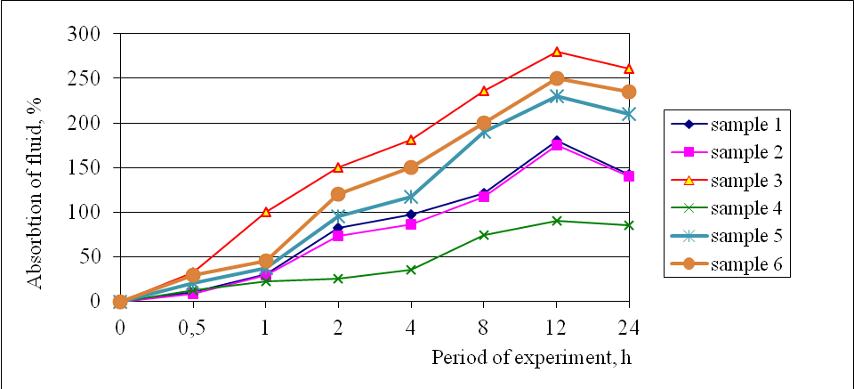
Pic. 1. The osmotic activity of model samples.

Screening result shows that the model samples ointment bases for 24 h exhibit a pronounced osmotic activity.
So, after 12 hours the highest osmotic activity - 280 ± 1,5 % ointment bases was like number 3 , made on the basis polietylenoksyd. This high osmotic activity will provide a beneficial effect on treating purulent exudate wounds.
In the experiment at 12 hours showed the smallest osmotic effect pattern number 4 - 90 ± 2,4 %. Given the low osmotic activity of this sample, this basis is impractical to use for making ointments for the treatment of wound healing in the transition of the first phase to the second.
Studies have shown that ointment bases of number 1 and number 2 show similar osmotic properties (180,0 ± 3,5 %; 175,2 ± 4,3 % respectively).
Moderately higher osmotic properties of the samples showed ointment bases number 5 and number 6 (230,3 ± 2,4 %; 250,2 ± 3,6 % respectively).
Therefore, further studies selected base number 3, which contains a fusion of PEO -400 and PEO -1500.
We know that the greatest stability, high dispersion and necessary visco- plastic properties of emulsions using mixtures of emulsifiers provides first and second types in certain relationships that determine important information about the function of interfacial surfactants [1, 3].
An important factor that determines the properties of emulsions are supramolecular structure of aggregates formed emulsifiers [2, 6]. Research in this direction is relevant, because on the basis of their results can be manipulated as physicochemical and biopharmaceutical properties soft medicines: release and bioavailability of drugs, osmotic activity, harmless and others. [3].
When choosing an emulsifier is accounted for not only its ability to form a stable emulsion , consistent with relevant properties, but also the need to ensure easy mixing ointment with serous secretions and purulent exudate.
For this purpose, based on market research pharmaceutical market was the choice of emulsifiers - MSG and alcohol tsytostearylovoho . MSH concentration was 3 %, and alcohol tsytostearylovoho - 5 %, which is reasonably previous studies [1, 8].
As an oil phase used vaseline oil – 20 % (water phase - Purified water - up to 100 %). With this amount of oil possible to obtain a stable emulsion with satisfactory performance and consumer visco- plastic characteristics [8].
The next stage of our research was to determine the influence of the concentration of non-aqueous solvents and, in particular glycerol in osmotic properties of the chosen based on previous studies of the model ointment bases (№ 3). Non-aqueous solvent is injected to the finished emulsion at a temperature of 40 ± 2 °C.
It should be noted that the use of glycerol as a part of ointment bases after the active phase following phase osmosis "reverse osmosis". This solvent is able to penetruyuchoho effect, allowing the molecule to pass into the aquatic environment through the membrane. Using these as a glycerol allows the creation of ointment bases long, but softer dehydrating effect.
In order to study the quantitative content of osmotically active solvent composed of ointment bases we selected glycerol in different concentrations (2,5 %, 5 %, 7,5 % and 10 %, and studies its osmotic activity. Composition variability glycerol concentrations shown in table 2, and the composition of the emulsion on reasonable due diligence.
Table 2
Ointment bases, depending on the concentration of glycerol
Name of GNS  № з⁄п | Model samples
 | 1 | 2 | 3 | 4
Glycerol | 2,5 | 5,0 | 7,5 | 10,0

The results of experimental determination of osmotic activity model ointment bases, depending on the concentration of glycerol are shown in Pic. 2.
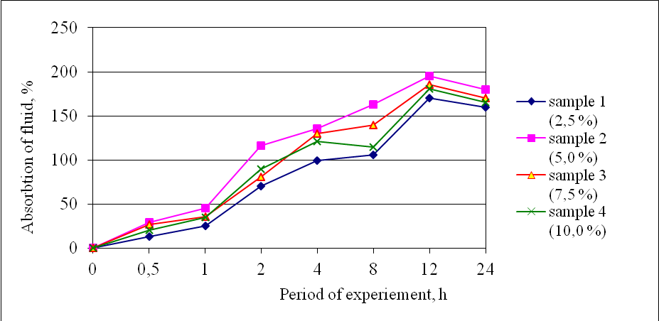
Pic. 2. Osmotic properties of the model emulsion ointment bases, depending on the concentration of glycerol.

Studies have shown that the model samples 1, 3 and 4 showed significant osmotic properties after 12 h (160,0 ± 2,7 %; 170,2 ± 2,5 %; 165,2 ± 2,1 % respectively). However, like a number 2 is significantly different absorption capacity (195,5 ± 2,7 %). This moderate interest rate of osmotic activity allows for the removal of purulent discharge from the affected tissues show anti-inflammatory activity and provide long , but softer dehydrating effect.
Previous studies prof. L. Davtyan [3] osmotic activity by soft medicines conventionally been divided into small ( 83 %), medium (up to 193 %) and a high osmotic activity ( 240 %). Based on the foregoing, and the survey results processed emulsion ointment base has a high osmotic activity. In our case, this is due to both foms and adjuvants.
Thus the basis of these studies, we osmotic reasonable basis for the composition of the emulsion ointment containing 5,0 % glycerol.
Conclusions
1. Based on experiments osmotic properties ointment bases chosen the best medium for the ointment - the foundation based on PEO -1500 and PEO -400, osmotic properties which allow for the removal of purulent discharge.
2. Investigated osmotic properties of emulsion ointment bases from vaseline oil with different surfactants.
Experimentally, the moderate dehydrating effects among combinations of emulsifiers has a model emulsion containing 5,0 % alcohol tsytostearyl and 3,0 % glycerol monostearate containing excipients (vaseline oil – 20 %, glycerol – 5 %, purified water - up to 100 % ).
3. According to the results of in vitro studies revealed that the proposed emulsion ointment base has a high osmotic activity.
4. On the basis of osmotic studies, we proved a basis for the composition of the emulsion ointment: PEO - 400 -4 % PEO -1500 – 1 %, 3 % MSG, alcohol tsytostearyl – 5 %, 5 % glycerol, vaseline oil – 20 % of purified water - to 100 %.
LITERATURE
1. Воловик Н. В. Создание мягких лекарственных средств на различных основах. Сообщение 2. Исследование реологических свойств гелей, образованных карбомерами ⁄ Н. В. Воловик, Н. А. Ляпунов // Фармаком. – 2001. – № 2. – С. 1 – 10.
2. Гладух Є. В. Вивчення осмотичної активності емульсій першого роду / Є. В. Гладух // Вісник фармації. – 2002. – № 4 (32). – С. 38 – 41.
3. Давтян Л. Л. Вивчення осмотичних властивостей модельних основ залежно від носія / Л. Л. Давтян // Фармац. журн. – 2003. – № 3. – С.74 – 77.
4. Допоміжні речовини та їх застосування в технології лікарських форм: довідковий посібник / Ф. Жогло, В. Возняк, В. Попович [та ін.]. – Львів: Центр Європи, 1996. – 95 с.
5. Перцев И. М. Фармацевтические и биологические аспекты мазей / И. М. Перцев, А. М. Котенко, О. В. Чуешов, Е. Л. Халаева. // Харьков: Издательство НФаУ „Золотые страницы”, 2003. – 288 с.
6. Сучасне медикаментозне лікування ран (Відомча інструкція). − Київ. − 2002. − 35 с.
7. Chren M. A cost analysis of topical drug regimens for dermatophyte infections / M. Chren, C. S. Landefeld // JAMA. – 1994. – N 22. – P. 1922 – 1925.
8. Gray J.E., McNamee P.M. Preservatives – their role in cosmetic products // Scientific Rewiew Series. – 2000. – Vol. 1. – P. 38-49.
9. Maisch T. Anti-microbial photodynamic therapy: useful in the future / T. Maisch // Lasers In Medical Science. – 2007. – Vol. 22, № 2. – P. 83 – 91.
10. Young R. Introduction to Polymers / R. Young, P. Lovell. London: Chapman&Hall, 1996. – 487 с.

